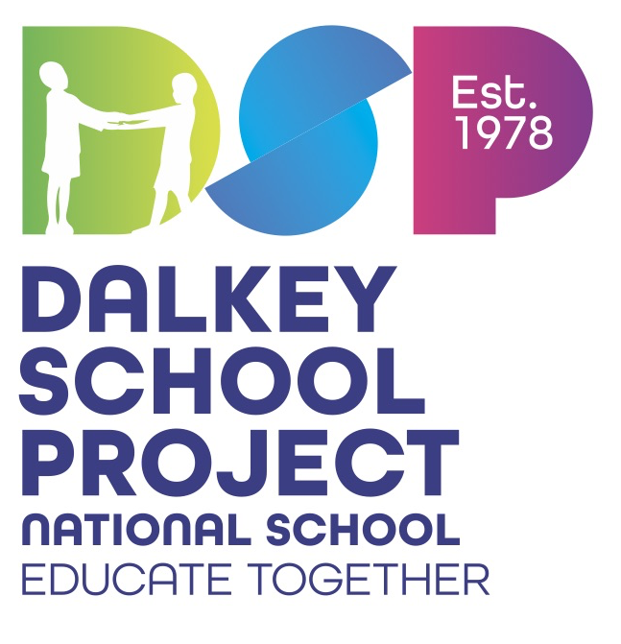

Dear Parents/Guardians

The Primary Schoolbooks Scheme grant will cover the cost of workbooks, copybooks and some related classroom resources. The books and most resources have already been ordered and are ready to go for next year. We have received our IT grant for purchase of equipment this year so thankfully payments by parents to the school to fund additional resources and supports is less this year.

|  |  |
| --- | --- |
| Payment to the school | |
| I.T. Maintenance/ Digital Education | €30 |
| The annual subscription fee of €3 to Dalkey School Project Executive and of €15 to Educate Together | €18 |
| **Total** | **€48** |

*Please pay online through the Aladdin Connect epayments option. If you have any difficulties with the cost please speak to the Principal in confidence. Requests will be strictly confidential.*

|  |
| --- |
| **Additional Items Required** |
| Set of whiteboard markers  & 1 Mini Whiteboard (LWBLA4) |
| 3 x Glue stick (large)/ A long ruler (TP70) |
| 2 x Blue, 2 x Black writing pens |
| 4 colour pen (TP63)//4 x pencils (TP55)/ A set of colouring pencils |
| 1 X A4 Plastic Folder |
| 1 X A3 Plastic Folder |

As a way of reducing waste and showing care for our environment, we strongly urge you and your child to reuse any equipment you can for next year. Reduce, Reuse, Recycle!

We hope you have a wonderful summer.

See you in September!

3rd Class Team