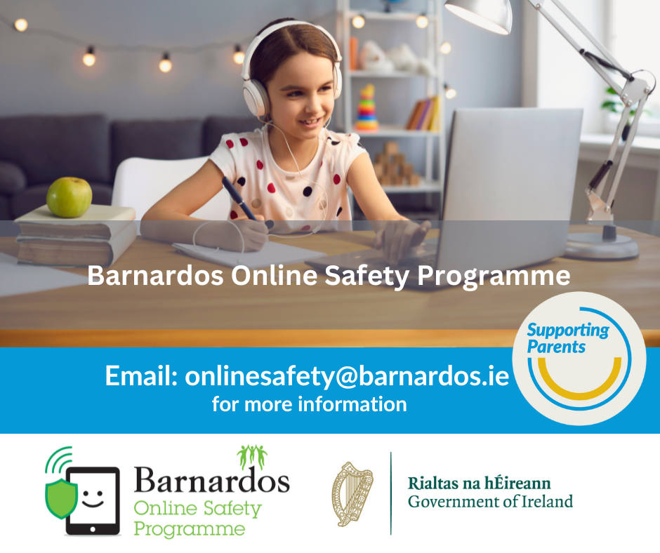

Barnardos is hosting a free public parent webinars to assist parents to create an open dialogue with their children about online safety.   
  
Supported by Google.org, our webinars are 60 minute sessions delivered via zoom.   
  
Topics covered include  
  
How to talk to your child about online safety  
  
Risks online for children (sexting, grooming, cyberbullying)  
  
Screen-time, gaming and how to encourage digital wellbeing  
  
Helpful websites and Q+A with our experienced trainer

When: Tuesday 7th May, 11am-12pm

Where: [**https://us02web.zoom.us/webinar/register/WN_n8M3qQXJTWSNkV0Ma68dmQ**](https://us02web.zoom.us/webinar/register/WN_n8M3qQXJTWSNkV0Ma68dmQ)

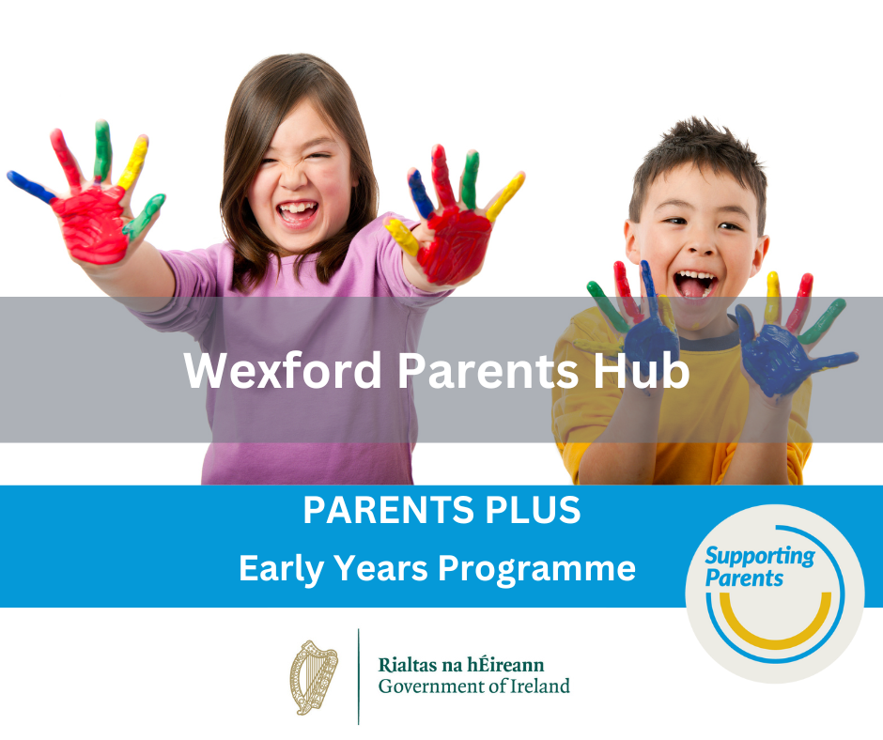

An evidence based programme promoting confidence, learning and positive behaviour in children aged 1-6 years.

Tuesday 21st of May, 9.30 to 12.

Gorey Youth Needs Group (Y25 T8P8)

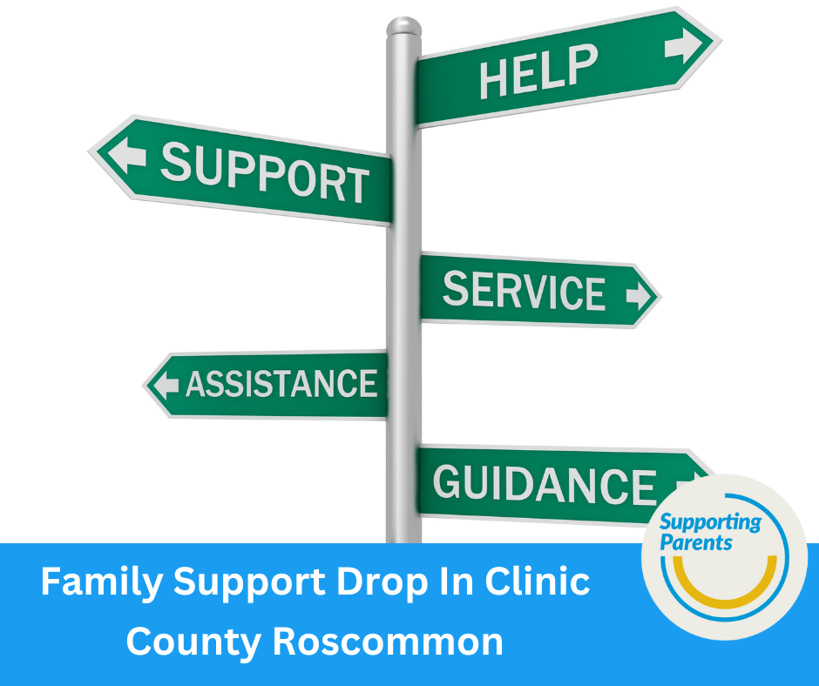

A space for parents & care givers of a child with additional needs/diagnosis or awaiting a diagnosis. This is a chance to meet with other parents of children with additional needs, provide peer support to one another, guest speakers will also be in attendance on relevant topics for the group.

Meeting on the last Friday of every month from 9.30am to 11am.Location: Boyle Family Resource Centre, Knocknashee, Boyle, Co.Roscommmon F52H674Contact: [info@boylefrc.ie](mailto:info@boylefrc.ie)

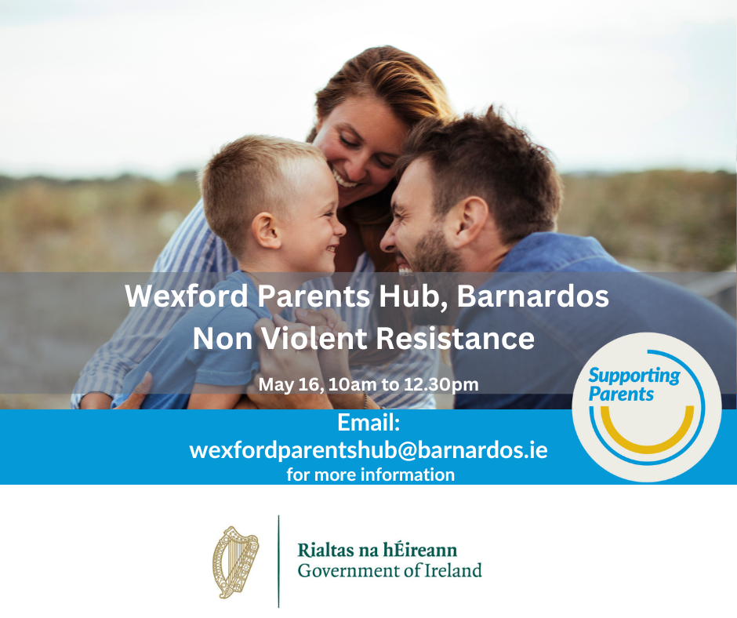

Non-violent resistance (NVR) is a supportive program for parents that are experiencing child to parent violence.Barnardos, Castle Hill, Enniscorthy, Co. Wexford.

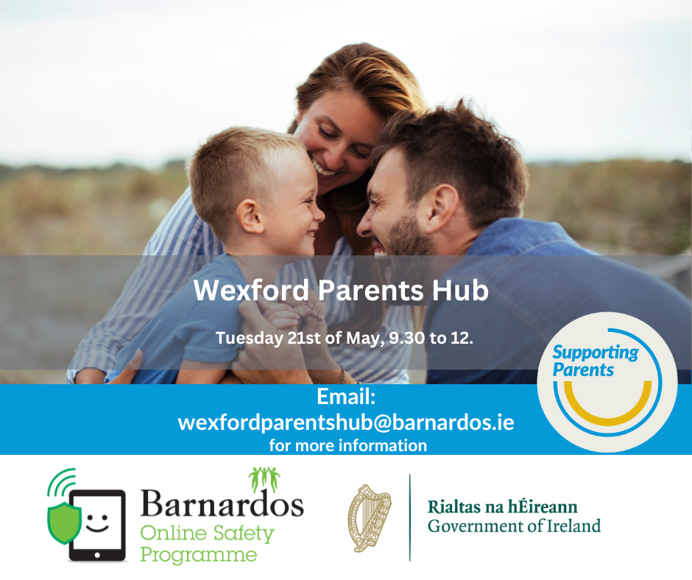

Non-violent resistance (NVR) is a supportive program for parents that are experiencing child to parent violence.Barnardos, Castle Hill, Enniscorthy, Co. Wexford.

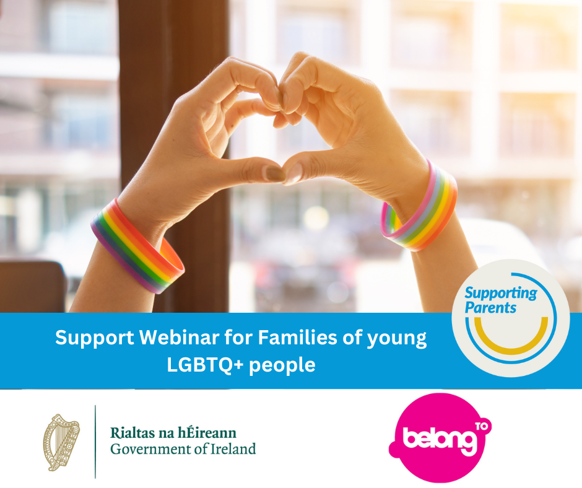

As part of our new Family Support Service, we are hosting a Webinar for the Parents and Carers of LGBTQ+ young people.

This free, one-hour workshop will take place online on Tuesday, May 7th at 7pm.

In this workshop, we will cover the following topics:

* Supporting Your Child,
* Supporting Yourself,
* Terminology And Language

For some parents and family members, it can be a challenging time when their child comes out as LGBTQ+. It is normal to feel confused, upset or that you don’t know enough. At Belong To, we are here to help. Sign up via this link below

<https://us02web.zoom.us/meeting/register/tZUkdumorj0qGdI6LLOQ8vXPMNRdXBnzEwzQ>

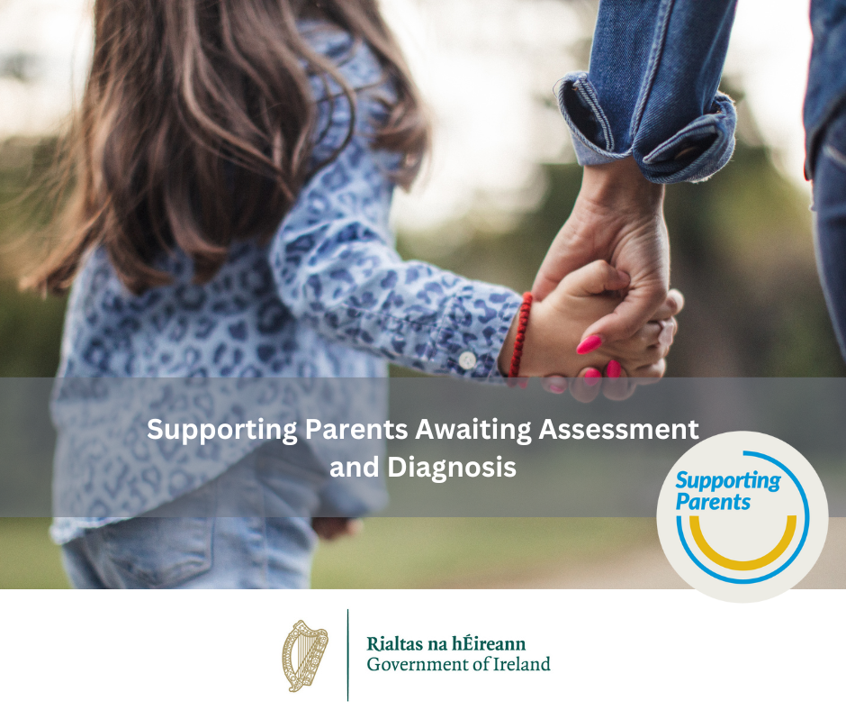

This online workshop will offer practical support and tips for parents to aid understanding of their child’s development, their role as a parent and to enhance progress during this stage.

Wednesday 29th May 2024 7pm - 8pm

Guest speaker: Helga Tinneny

To register click on the Eventbrite link below:

<https://www.eventbrite.ie/e/supporting-parents-awaitingassessment-and-diagnosis-tickets-894388448927>

w